Sheet 1 of 10
Figure 1
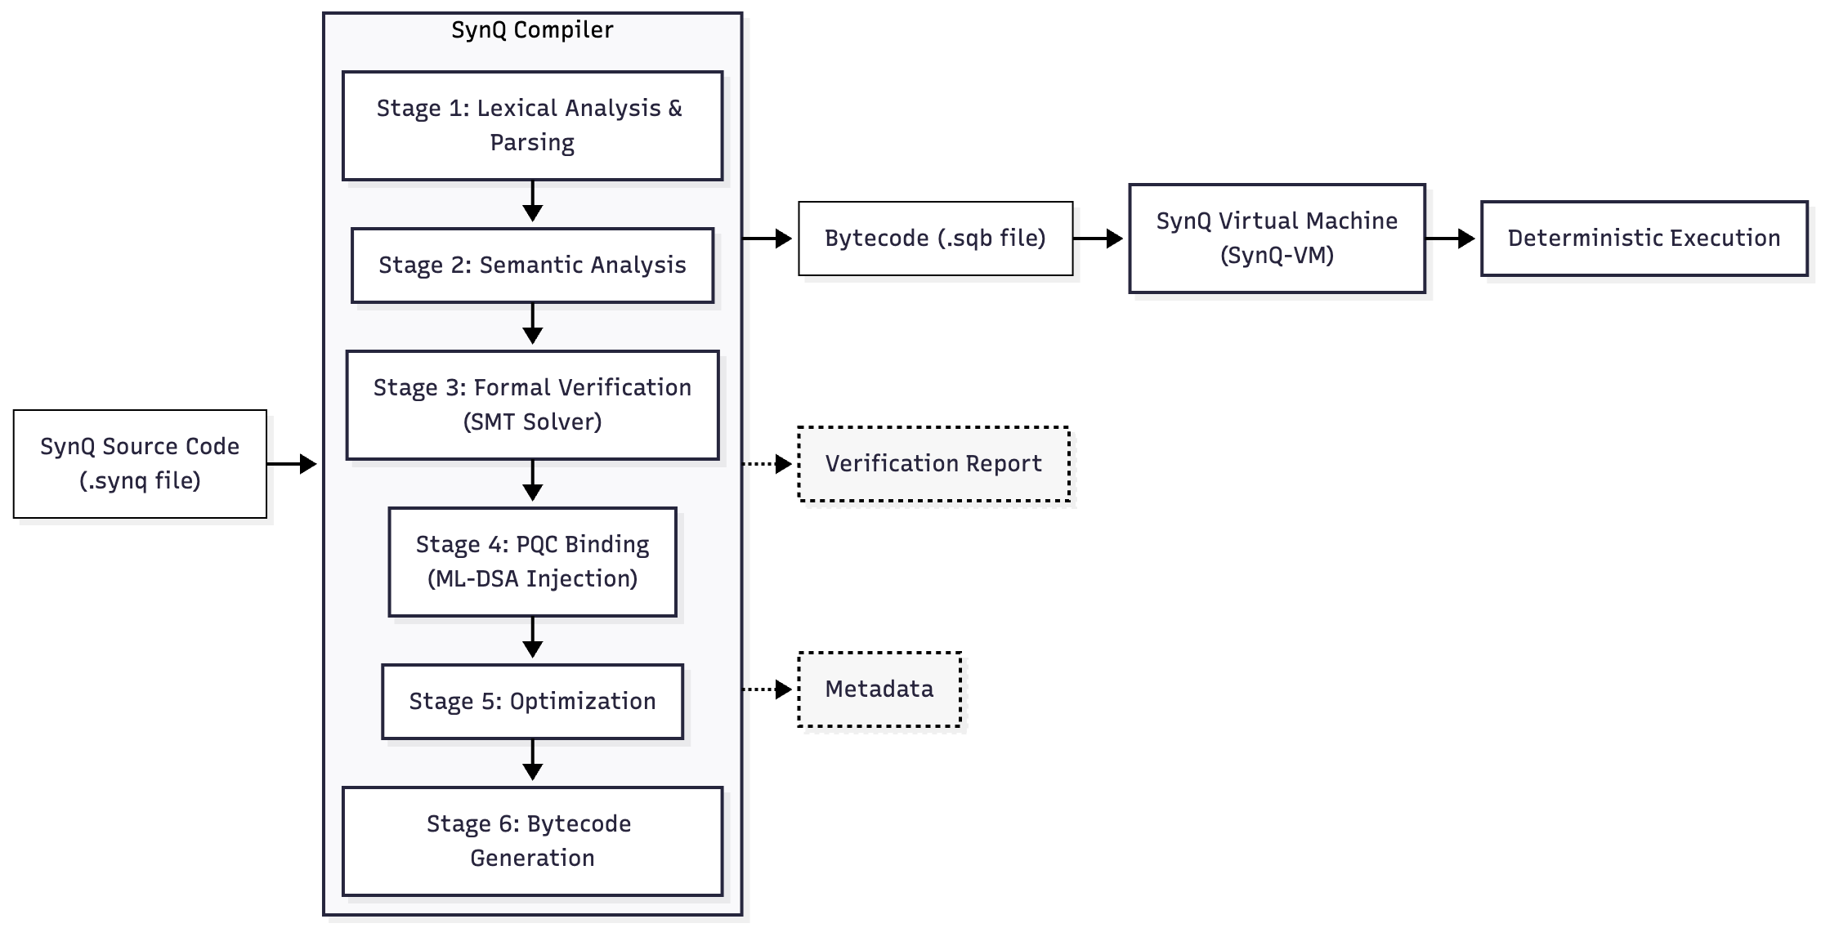
Compilation Flow

Sheet 2 of 10
Figure 2
VM Stack Architecture
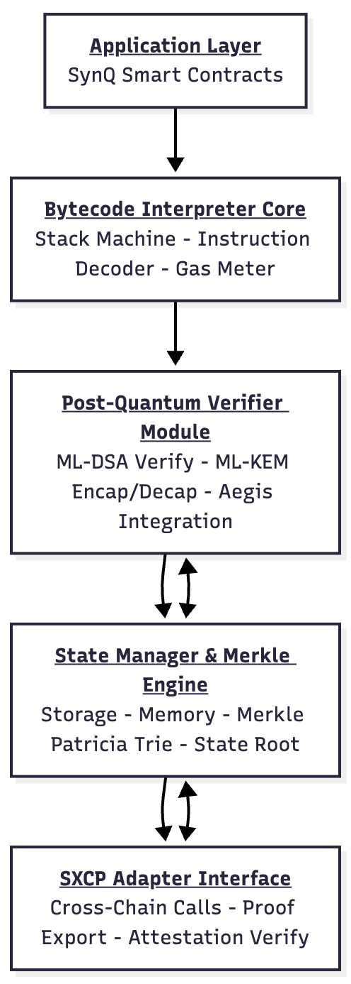

Sheet 3 of 10
Figure 3
Abstract Syntax Tree Structure
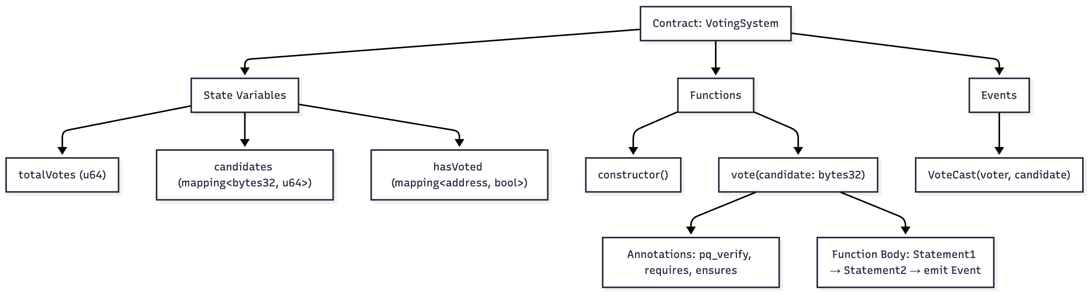

Sheet 4 of 10
Figure 4
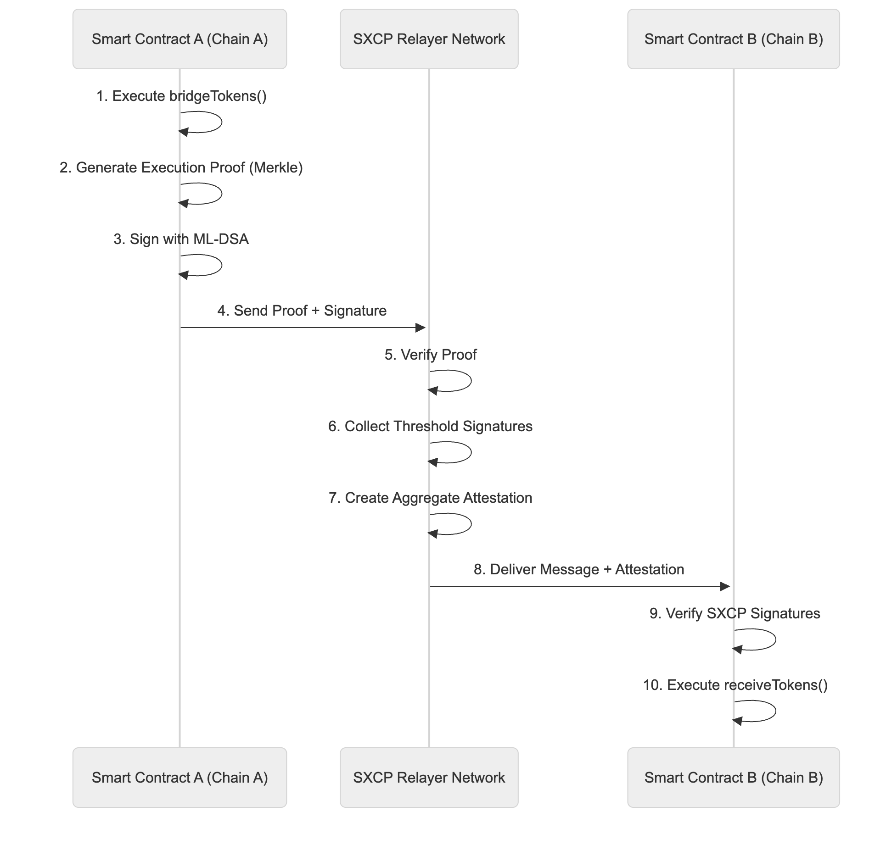
Cross-Chain Message Flow

Sheet 5 of 10
Figure 5
State Transition and Merkle Proof Generation
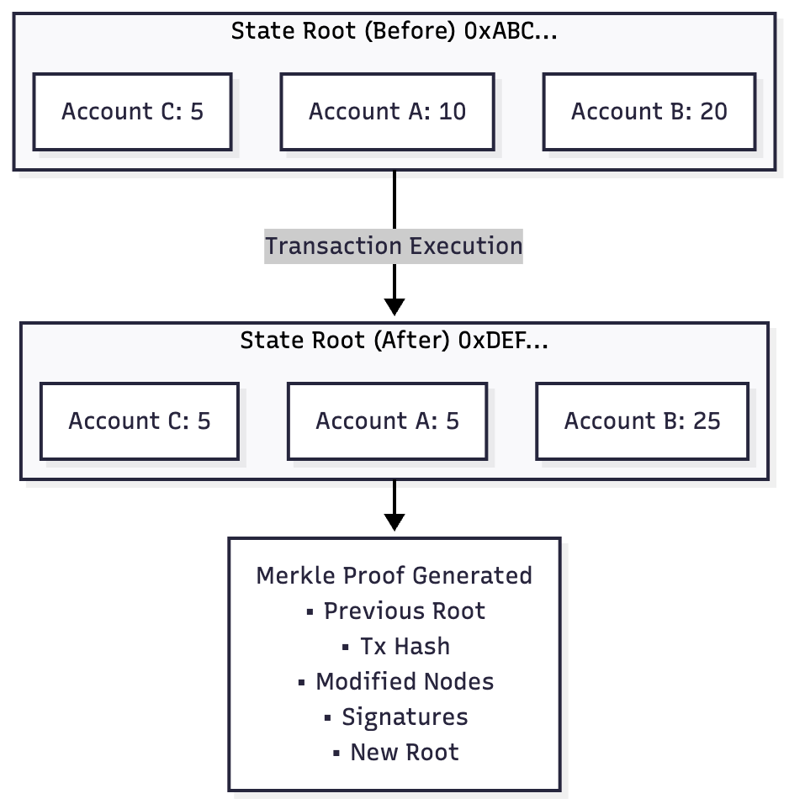

Sheet 6 of 10
Figure 6
Formal Verification Pipeline
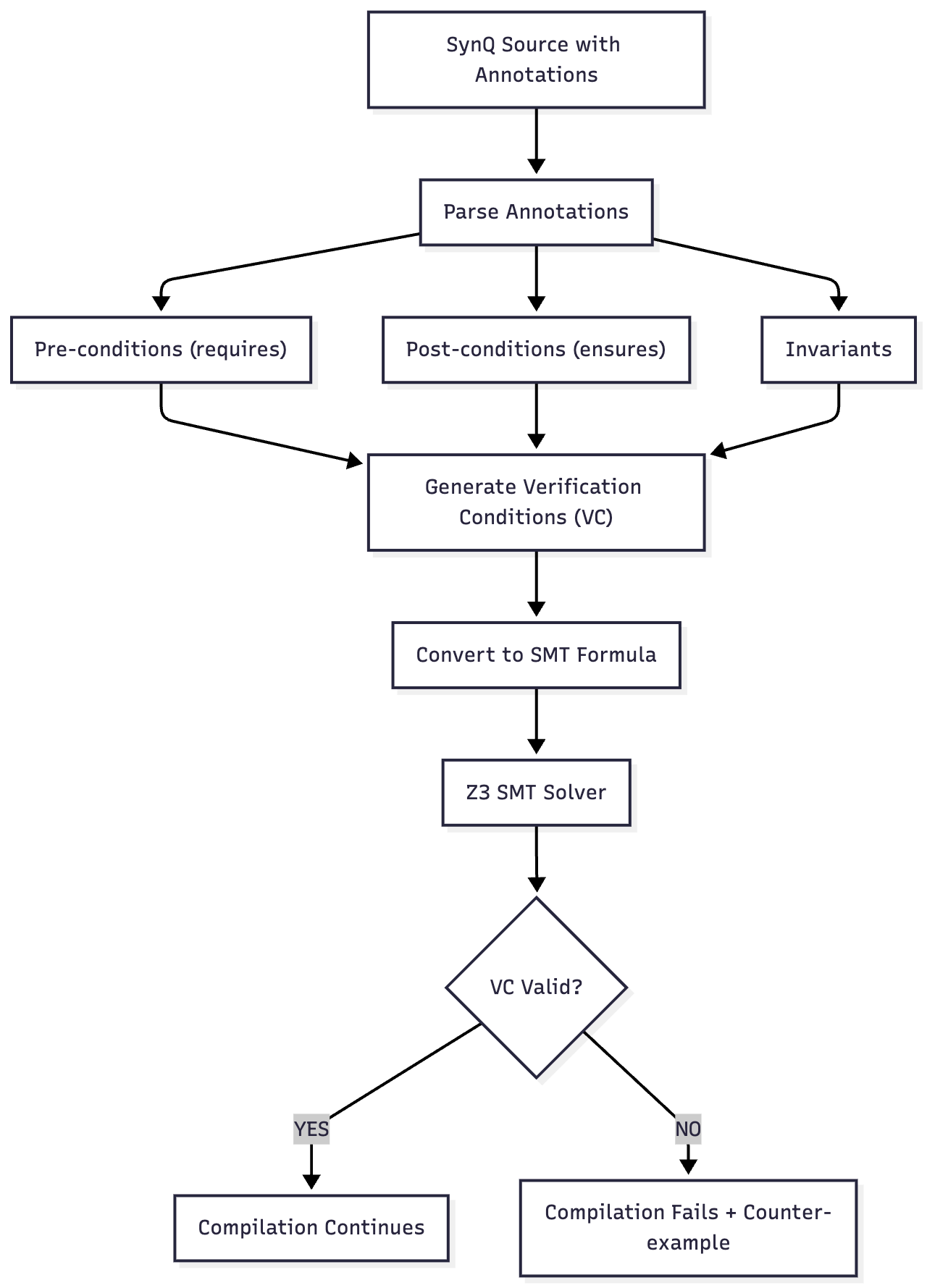

Sheet 7 of 10
Figure 7
Governance Rollback Process

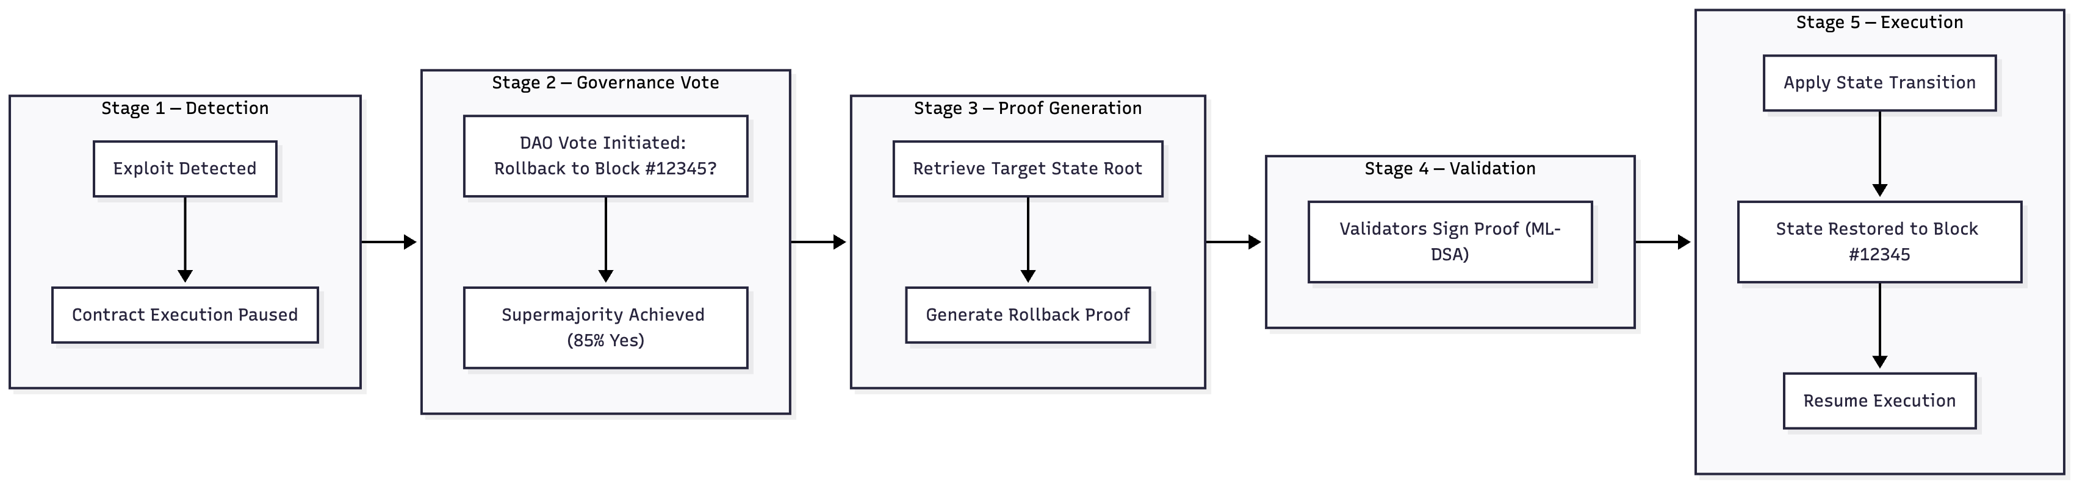

Sheet 8 of 10
Figure 8
Deterministic Gas Metering
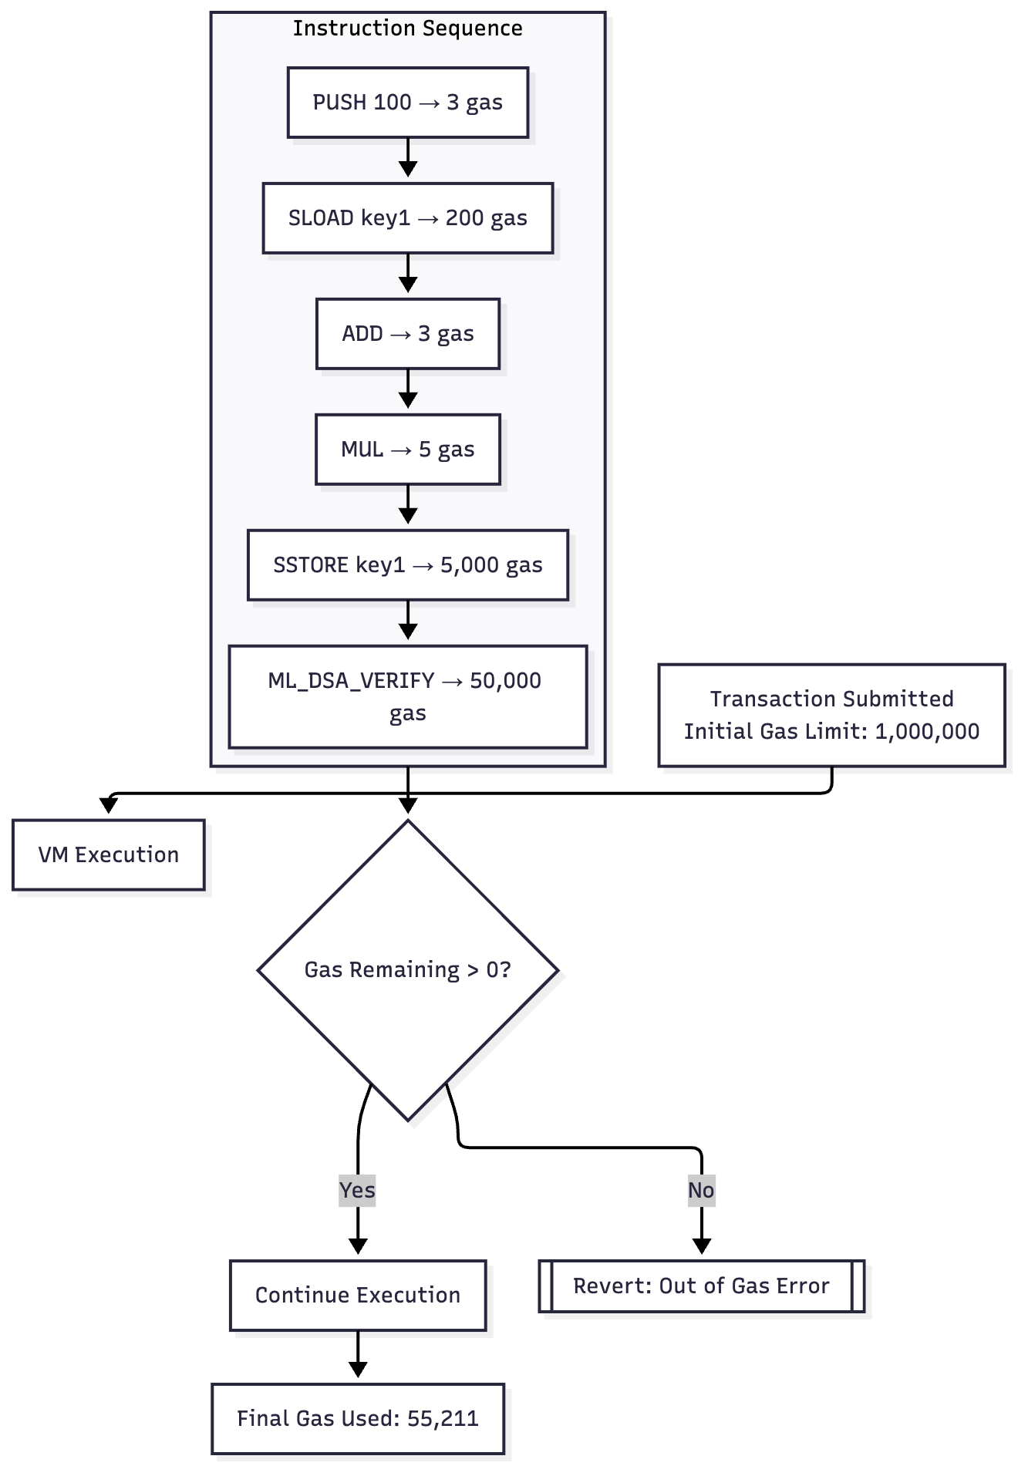

Sheet 9 of 10
Figure 9
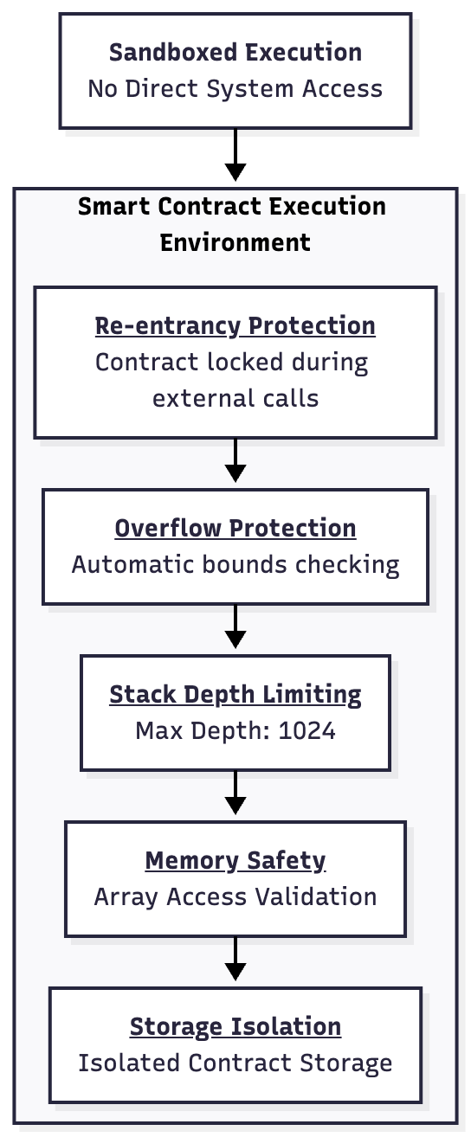
Security Architecture

Sheet 10 of 10
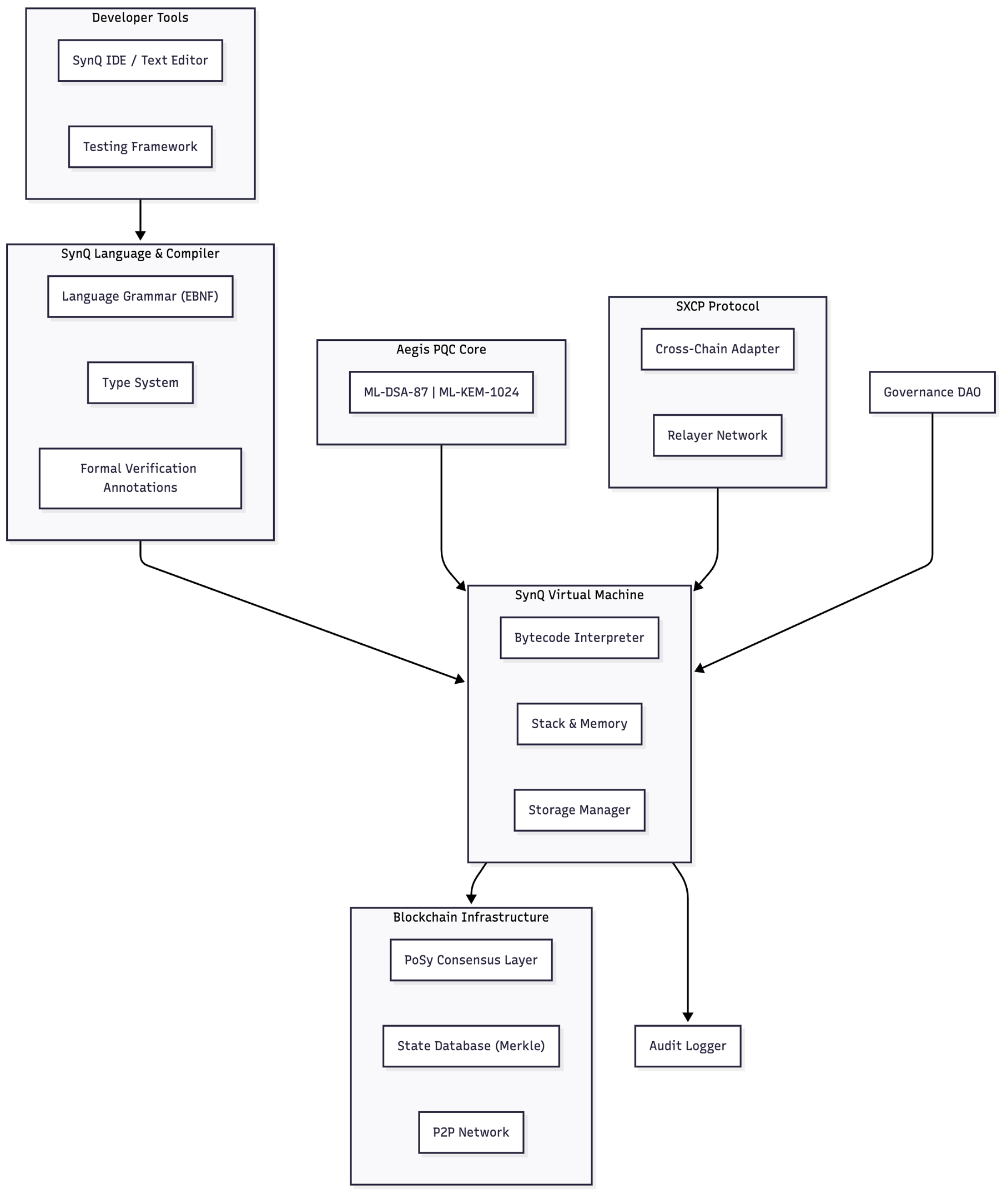
Figure 10
Complete System Architecture

